**­­­**

Class 8

**Lecture \***

**Digital Electronics**

**Digital Electronics**



**Lab Objectives:**

* Introduction to Digital Electronics.
* Number System.
* Different types of Number System.

**Digital Electronics**

Digital Electronics is the sub-branch of electronics which deals with digital signals for processing and controlling various systems and sub-systems. In various applications like sensors and actuators, usage of digital electronics is increasing extensively.

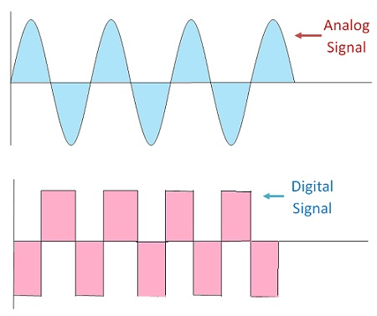

**Advantages of Digital Systems**

* **Easier Designing**: The Digital systems can be easily designed as they involve digital signals. These signals do not require exact value at a particular time but it consists of range of particular values of voltage. Thus, it comprises of basically two values 0 and 1 I.e high or low.
* **Noise Immune:** Digital systems are noise immune because digital signal consists of range of particular values. Thus, when noise is introduced in the medium and digital signal and analog signal both passes through it.
* **Information Storage is Simpler:** The storage of information in digital systems is easy. It can be stored by latching thus, the it can be stored for a long period of time.
* **High Accuracy And Precision**: The digital signal offers high accuracy and precision. This is because the processing of digital signal is done through the switching circuit.
* **Programmable**: The digital systems are easily programmable but analog system becomes complex when excessive programming of components is done.

**Disadvantages of Digital Systems**

Everything comes up with pros and cons. Similarly digital systems too hold certain disadvantages which are as follows:-

**Expensive**: Digital systems are expensive because it involves switching elements.

**Analog nature of Real World Entities:** We need to convert the digital output in analog form because all the real world entities are analog.

**Digital to Analog and Analog to Digital Conversion**

These types of conversion circuits are required so that we can convert analog signal into digital and then process the digital signal using digital systems and convert back the digital signal into analog form so that it is can be understood by real world.

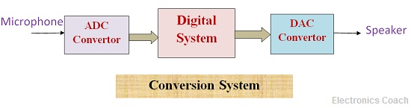

**Number System**

Number systems are the technique to represent numbers in the computer system architecture, every value that you are saving or getting into/from computer memory has a defined number system.

Computer architecture supports following number systems.

* **Binary number system**
* **Octal number system**
* **Decimal number system**
* **Hexadecimal (hex) number system**

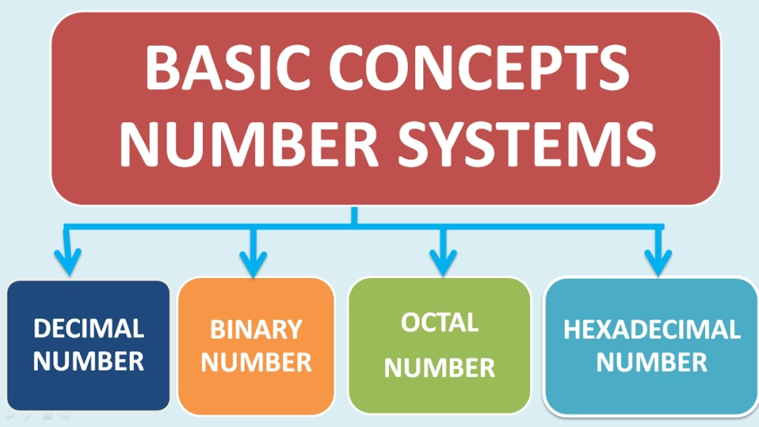

**Binary Number System**

A Binary number system has only two digits that are 0 and 1. Every number (value) represents with 0 and 1 in this number system. The base of binary number system is 2, because it has only two digits

All computing devices use binary numbering to represent electronic circuit voltage state (i.e., on/off switch), which considers 0 as off and 1 input as on. This is also known as the base-2 number system.

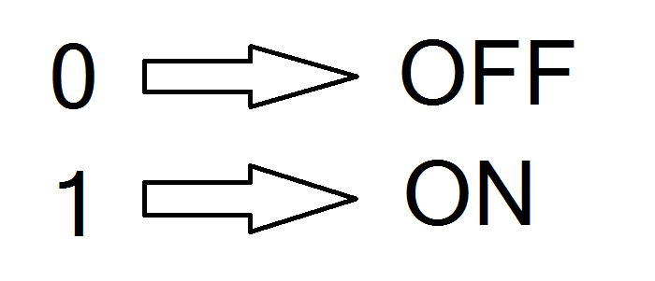

**Octal number system**

Octal number system has only eight (8) digits from 0 to 7. Every number (value) represents with 0,1,2,3,4,5,6 and 7 in this number system. The base of octal number system is 8, because it has only 8 digits.

**Decimal number system**

Decimal number system has only ten (10) digits from 0 to 9. Every number (value) represents with 0,1,2,3,4,5,6, 7,8 and 9 in this number system. The base of decimal number system is 10, because it has only 10 digits.

**Hexadecimal number system**

A Hexadecimal number system has sixteen (16) alphanumeric values from 0 to 9 and A to F. Every number (value) represents with 0,1,2,3,4,5,6, 7,8,9,A,B,C,D,E and F in this number system. The base of hexadecimal number system is 16, because it has 16 alphanumeric values.

Here A is 10,

B is 11,

C is 12,

D is 13,

E is 14 and F is 15.

